### Semester One Examination, 2022

### Question/Answer booklet

# MATHEMATICS SPECIALIST

**UNIT 3**

## Section Two:

## Calculator-assumed

|  |
| --- |
|  |

Your Name

Your Teacher’s Name

## Time allowed for this section

Reading time before commencing work: ten minutes

Working time: one hundred minutes

## Materials required/recommended for this section

***To be provided by the supervisor***

This Question/Answer booklet

Formula sheet (retained from Section One)

***To be provided by the candidate***

Standard items: pens (blue/black preferred), pencils (including coloured), sharpener, correction fluid/tape, eraser, ruler, highlighters

Special items: drawing instruments, templates, notes on two unfolded sheets of A4 paper, and up to three calculators approved for use in this examination

## Important note to candidates

No other items may be taken into the examination room. It is **your** responsibility to ensure that you do not have any unauthorised material. If you have any unauthorised material with you, hand it to the supervisor **before** reading any further.

|  |  |  |  |  |  |
| --- | --- | --- | --- | --- | --- |
| **Question** | **Marks** | **Max** | **Question** | **Marks** | **Max** |
| **9** |  | **7** | **16** |  |  |
| **10** |  |  | **17** |  |  |
| **11** |  |  | **18** |  |  |
| **12** |  |  | **19** |  |  |
| **13** |  |  | **20** |  |  |
| **14** |  |  | **21** |  |  |
| **15** |  |  | **22** |  |  |

**Structure of this paper**

|  |  |  |  |  |  |
| --- | --- | --- | --- | --- | --- |
| Section | Number of questions available | Number of questions to be answered | Working time (minutes) | Marks available | Percentage of examination |
| Section One:  Calculator-free | 8 | 8 | 50 | 52 | 35 |
| Section Two:  Calculator-assumed | 14 | 14 | 100 | 97 | 65 |
|  |  |  |  | **Total** | 100 |

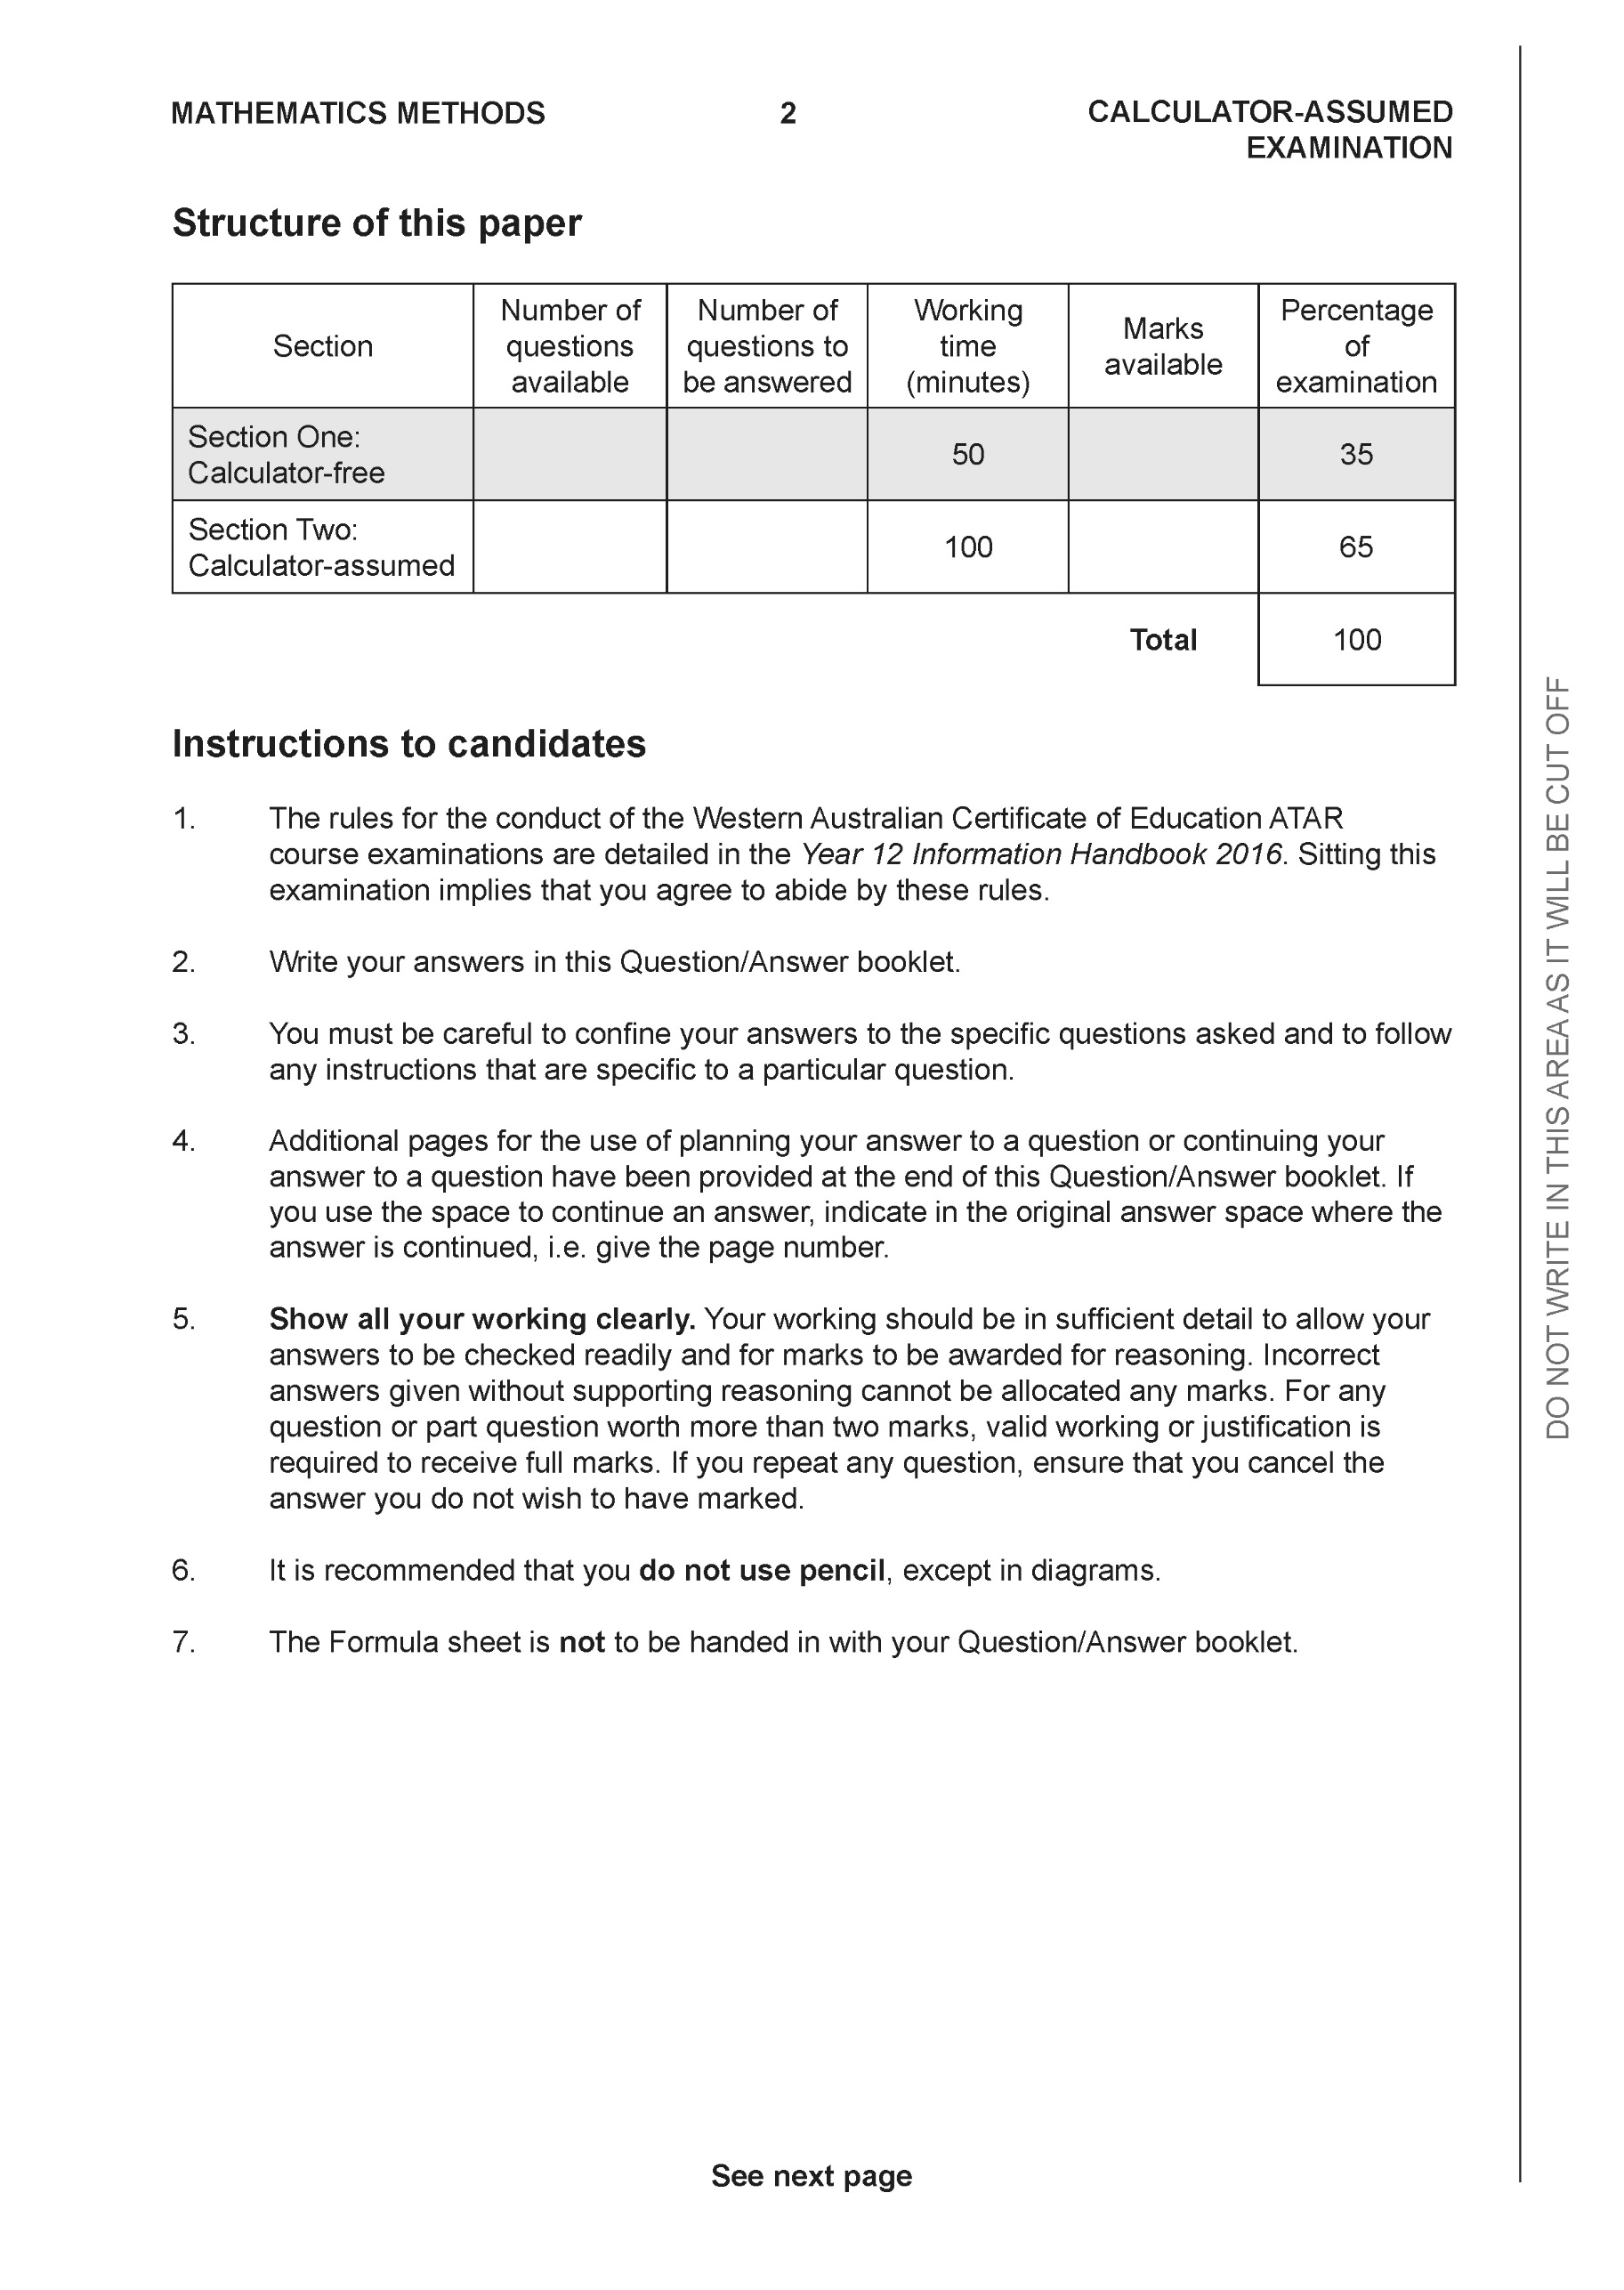

**Section Two: Calculator-assumed (97 Marks)**

This section has **14** questions. Answer **all** questions. Write your answers in the spaces provided.

Spare pages are included at the end of this booklet. They can be used for planning your responses and/or as additional space if required to continue an answer.

● Planning: If you use the spare pages for planning, indicate this clearly at the top of the page.

● Continuing an answer: If you need to use the space to continue an answer, indicate in the original answer space where the answer is continued, i.e. give the page number. Fill in the number of the question that you are continuing to answer at the top of the page.

Working time: 100 minutes.

**Question 9 (7 marks)**

Consider the complex numbers  plotted on the Argand plane below.

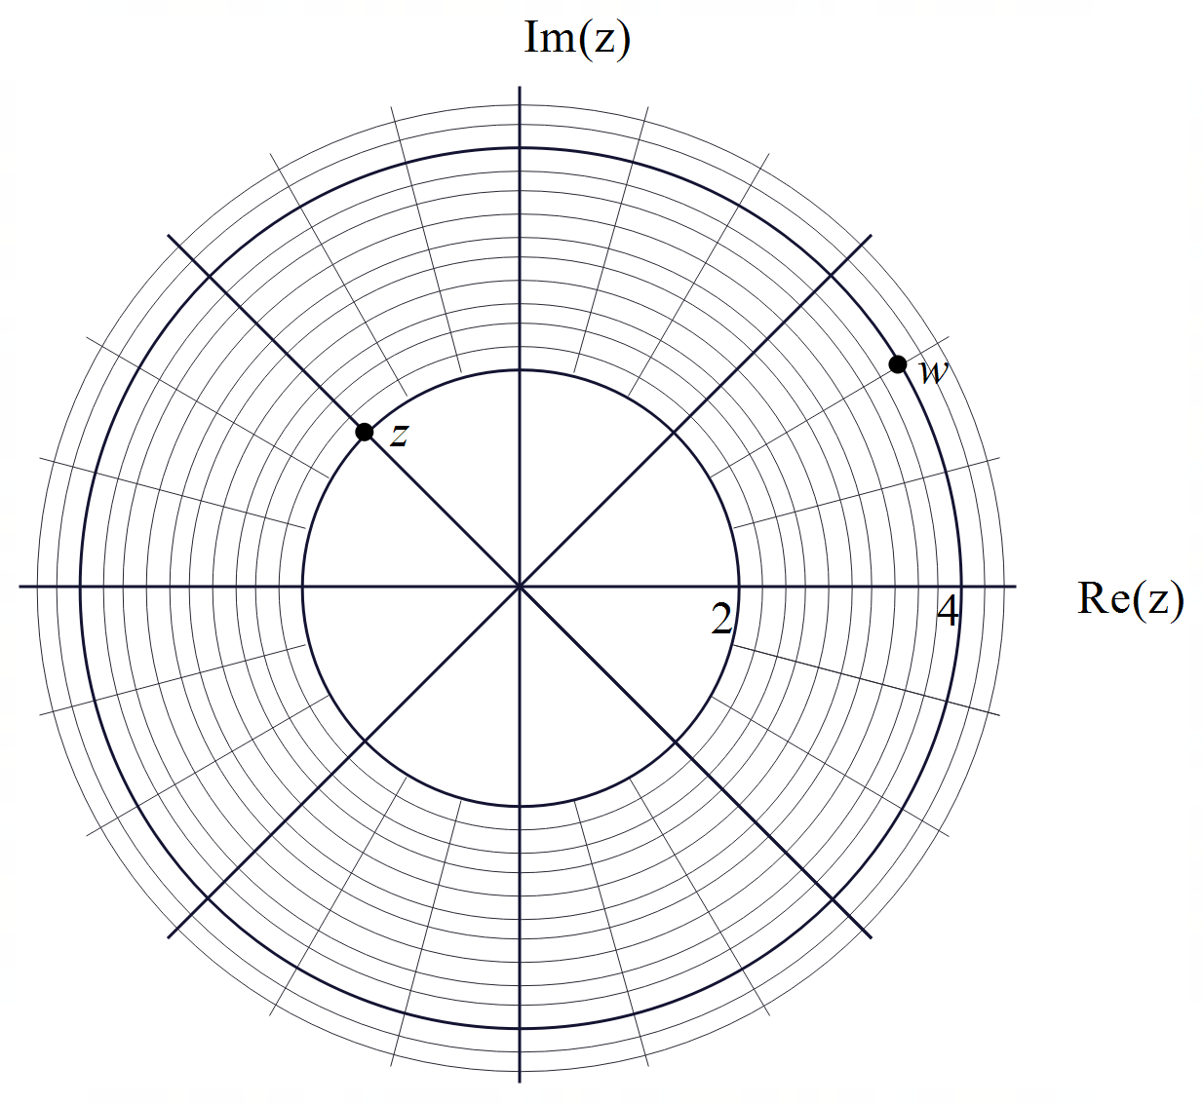

1. Express  in polar form with principal argument. (2 marks)

|  |
| --- |
| **Solution** |
|  |
| **Specific behaviours** |
| P states argument (unsimplified)  P states modulus |

1. Express  in cartesian form. (2 marks)

|  |
| --- |
| **Solution** |
|  |
| **Specific behaviours** |
| P polar form  P exact cartesian form |

1. Plot  on the axes above. (3 marks)

|  |
| --- |
| **Solution** |
|  |
| **Specific behaviours** |
| P uses rotation around origin for both  P correct argument of iz  P correct argument of -iw |

**Question 10 (10 marks)**

Consider the region shaded in the Argand plane below.

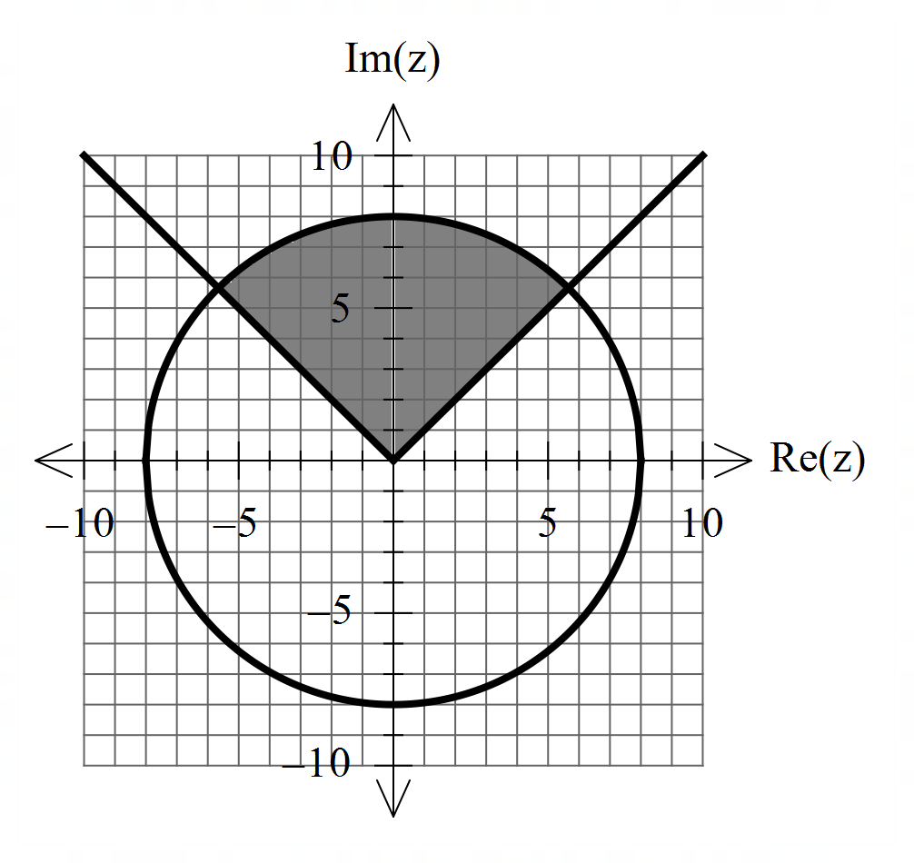

1. In terms of , describe the region of complex numbers shaded above. (4 marks)

|  |
| --- |
| **Solution** |
|  |
| **Specific behaviours** |
| P uses the form  P states $c=0,r=8$ P uses form  P uses |

1. i) Sketch the locus  such that . (3 marks)

|  |
| --- |
| **Solution** |
|  |
| **Specific behaviours** |
| P plots a circle  P centre  P radius |

ii) Determine the maximum value of Arg() (3 marks)

|  |
| --- |
| **Solution** |
|  |
| **Specific behaviours** |
| P finds argument of circle centre  P uses tangent to find angle beta  P determines max argument in radians or degrees (4th quadrant) |

**Question 11 (8 marks)**

Consider a rectangular prism ,as shown below, with 

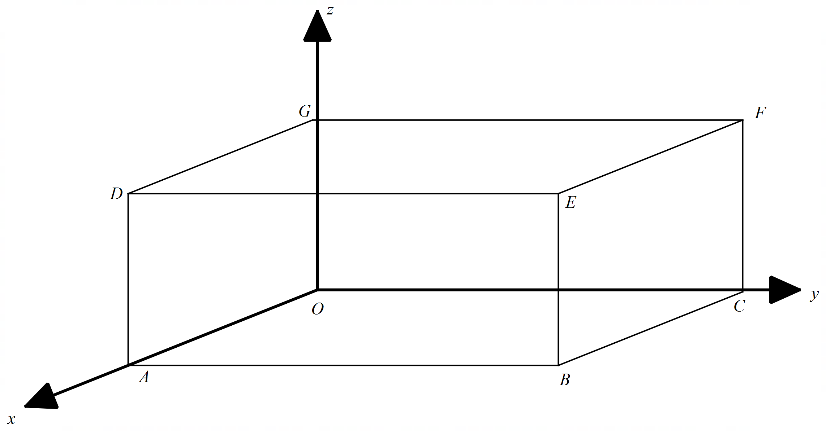

1. Prove that the diagonals  bisect each other using vector methods. (4 marks)

|  |
| --- |
| **Solution** |
|  |
| **Specific behaviours** |
| P determines diagonals  P defines two midpoints  P determines position vector of one midpoint  P determines position vector of both midpoints and shows identical |

Q11 continued-

1. Determine the exact vector equation of a sphere that goes through all vertices of the rectangular prism . (4 marks)

|  |
| --- |
| **Solution** |
| Midpoint of diagonals (5/2,7/2,2) |
| **Specific behaviours** |
| P identifies centre  P determines diameter or radius  P uses vector equation of a sphere  P gives exact equation |

**Question 12 (9 marks)**

Consider rockets  that are ignited at the same times from the following positions and constant velocities. (At time )



1. Prove using vector methods that the two rockets do not meet. (3 marks)

|  |
| --- |
| **Solution** |
|  |
| **Specific behaviours** |
| P determines vector equation in terms of t for one rocket  P determines vector equation in terms of t for both rockets  P shows that t values different for 2 components |

1. Determine the closest approach between the two rockets **using vector methods**.

(4 marks)

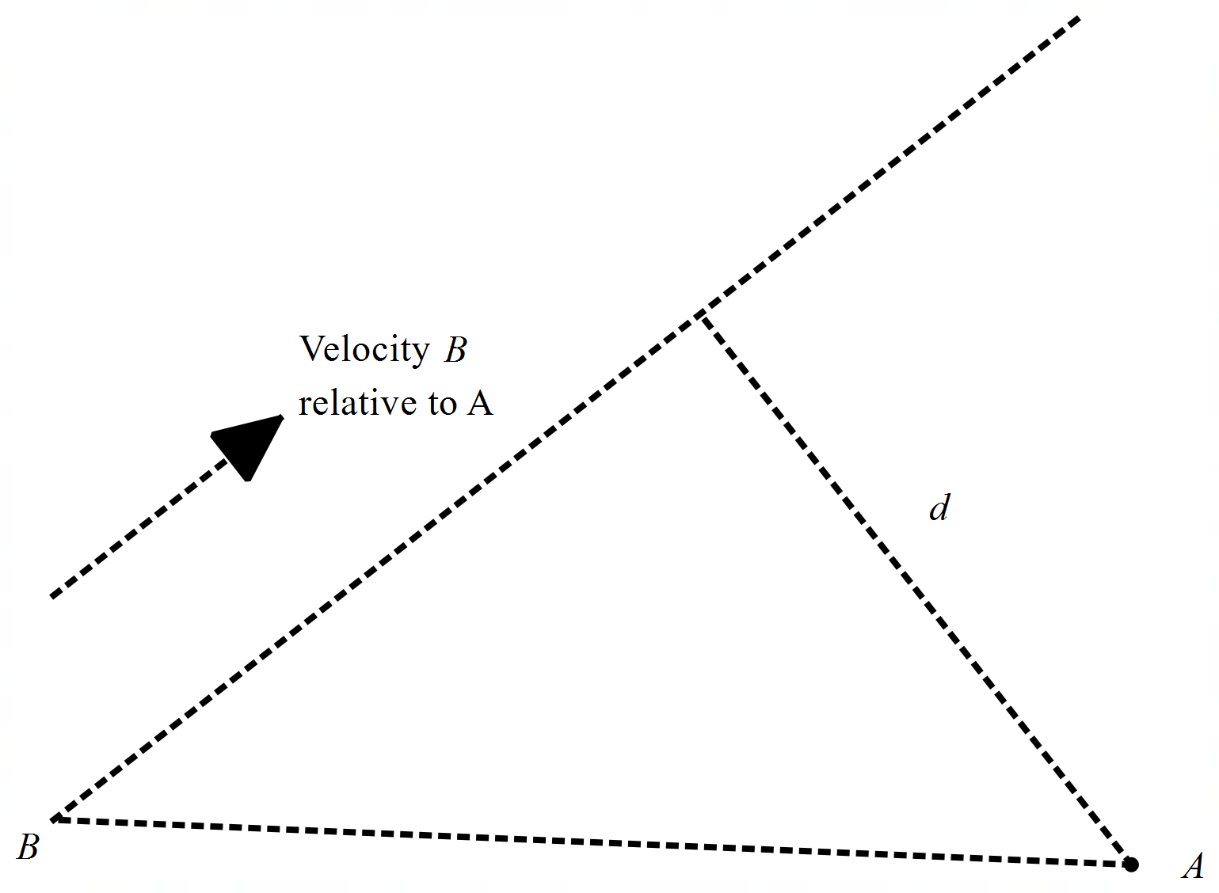

|  |
| --- |
| **Solution** |
|  |
| **Specific behaviours** |
| P uses relative velocity  P determines separation vector  P uses dot product to find time  P determines approx. closest distance  Note-max 2 marks if calculus used |

1. At time  hour, rocket  will change its velocity so that it will collide with rocket  at time  hours. Determine this new constant velocity of rocket  to 2 decimal places.

(4 marks)

|  |
| --- |
| **Solution** |
| Velocity = |
| **Specific behaviours** |
| P determines positions at t=1  P sets up one component equation form collision 2 hours later  P sets up 3 component equations  P solves for velocity components rounded to 2 dp, no need for units |

**Question 13 (6 marks)**

Consider the line  and the point .

1. Determine the distance of point  to the line using vector **dot** product. (3 marks)

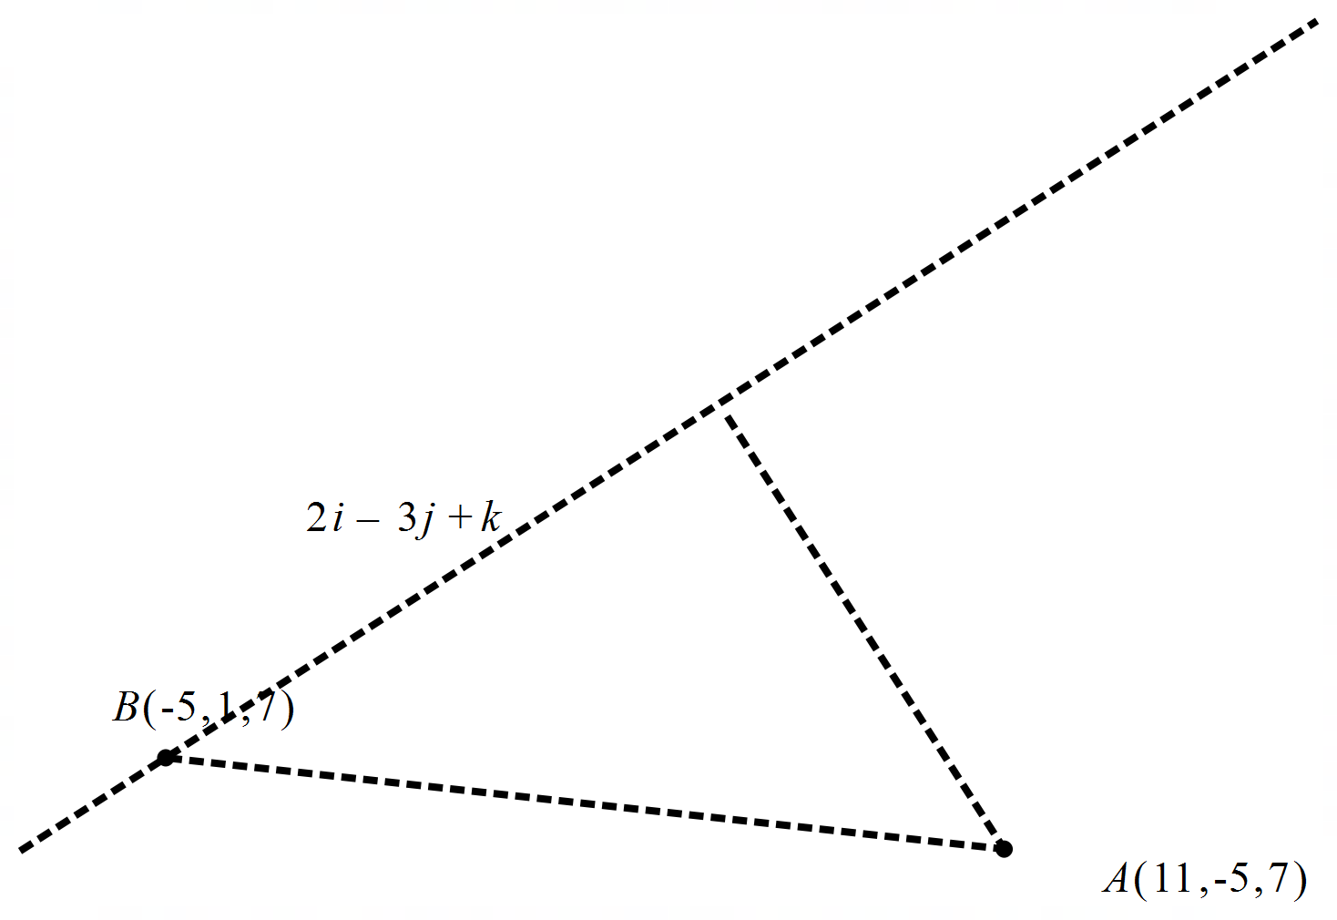

|  |
| --- |
| **Solution** |
|  |
| **Specific behaviours** |
| P sets up a separation vector  P uses dot product  P determines distance approx |

1. Determine the distance of point  to the line using vector **cross** product. (3 marks)

|  |
| --- |
| **Solution** |
|  |
| **Specific behaviours** |
| P sets up an expression with cross product  P determines separation vector using cross product  P determines approx. distance |

**Question 14 (7 marks)**

Consider the plane  which contains the line A,  and the **parallel plane**  which contains the line B,  as shown in the diagram below, (not drawn to scale).

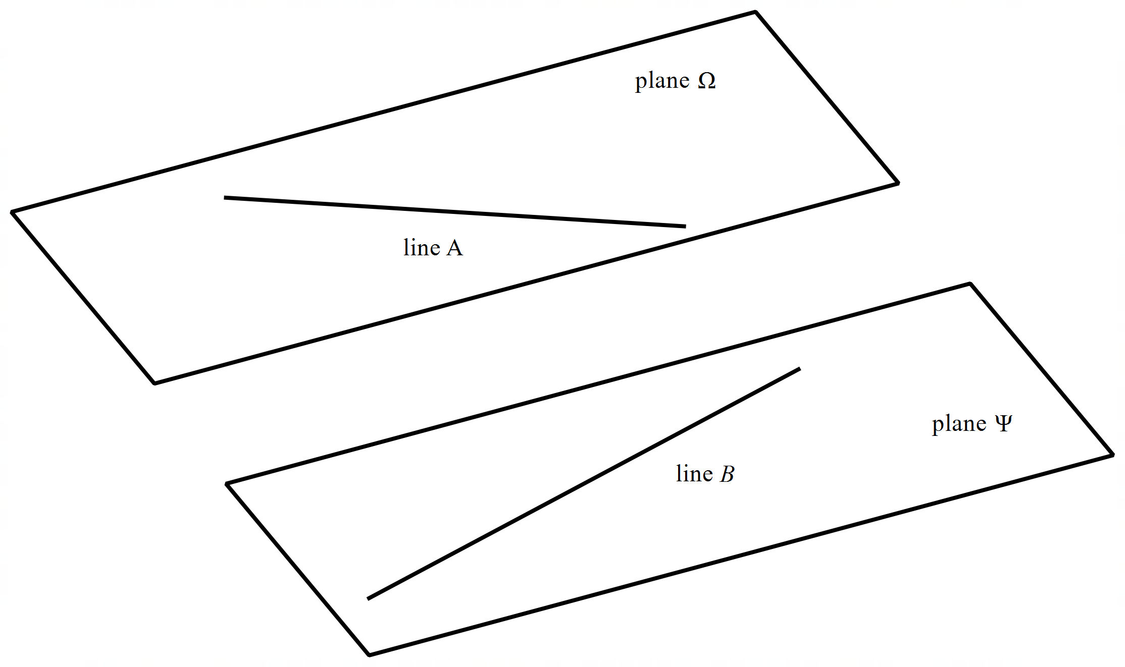

1. Determine the cartesian equation of plane  (3 marks)

|  |
| --- |
| **Solution** |
|  |
| **Specific behaviours** |
| P determines normal vector  P determines vector equation  P determines cartesian |

1. Determine the distance between the two planes. (4 marks)

|  |
| --- |
| **Solution** |
|  |
| **Specific behaviours** |
| P uses separation vector from a point on each plane  P uses unit normal vector  P uses dot product  P determines approx. distance (must be positive) |

**Question 15 (6 marks)**

Let  where .

1. Determine an expression for  in terms of  only. (simplify) (3 marks)

|  |
| --- |
| **Solution** |
|  |
| **Specific behaviours** |
| P converts all terms to polar (radians)  P determines simplified modulus  P determines simplified argument |

1. Determine an expression for  in terms of  only. (3 marks)

|  |
| --- |
| **Solution** |
|  |
| **Specific behaviours** |
| P shows isosceles triangle  P determines all angles in triangle  P determines argument in required form |

**Question 16 (9 marks)**

1. Determine the roots to  in the form  with . (4 marks)

|  |
| --- |
| **Solution** |
|  |
| **Specific behaviours** |
| P converts RHS to polar with positive modulus  P shows use of De Moivres  P determines modulus of each root  P determines all principal arguments |

Q16 continued-

1. Plot the roots from part a on the axes below. (2 marks)

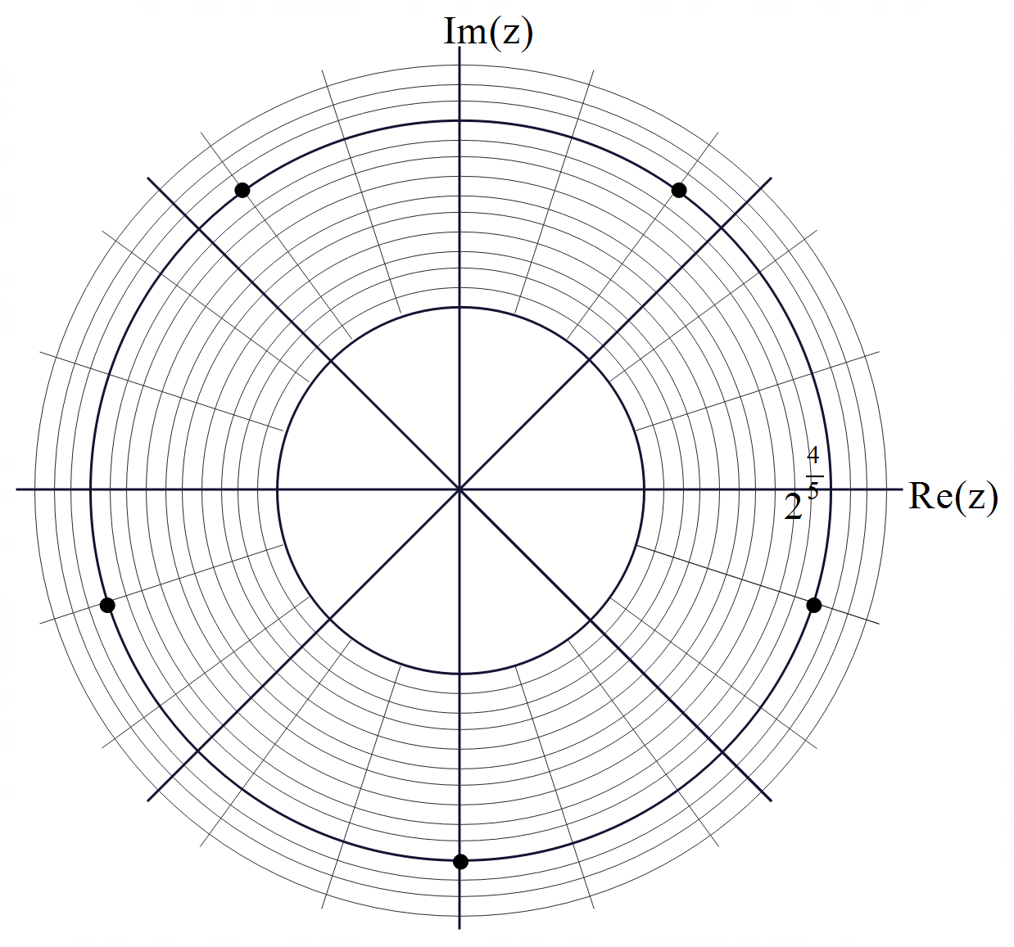

|  |
| --- |
| **Solution** |
|  |
| **Specific behaviours** |
| P scale shown and roots equally spaced  P correct positions on graph axes |

1. The roots above form a polygon, determine the perimeter of this polygon.

(3 marks)

|  |
| --- |
| **Solution** |
|  |
| **Specific behaviours** |
| P uses cosine rule  P determines the correct central argument  P states approx. perimeter (no need for units) |

**Question 17 (3 marks)**

Consider the locus of points that satisfy . Describe this locus identifying all major features.

|  |
| --- |
| **Solution** |
| Sphere  Centre |
| **Specific behaviours** |
| P states a sphere  P states coordinates of centre  P states approx. radius (no units) |

**Question 18 (7 marks)**

Consider the line  , is a constant and the sphere .

Determine all possible values of using **vector methods** such that:

1. The line is a tangent to the sphere.
2. The line passes through the sphere.
3. The line misses the sphere completely.

|  |
| --- |
| **Solution** |
| |  |  | | --- | --- | |  |  |   Tangent  =-9.44,15.44  Passes through  Not meeting |
| **Specific behaviours** |
| P states an equation with  using vectors````````  P states a discriminant with  only  P graphs this discriminant  P uses three scenarios for this discriminant  P states all values for tangent  P states all values for passing through  Pstates all values for missing sphere |

**Question 19 (4 marks)**

Simplify  showing all reasoning.

|  |
| --- |
| **Solution** |
|  |
| **Specific behaviours** |
| P uses double angle formula for cosine  P takes out common factors  P uses de Moivres or conjugates to simplify **inside** brackets  P states simplified result |

**Question 20 (4 marks)**

Consider .

1. Show that  where  is a positive integer. (3 marks)

|  |
| --- |
| **Solution** |
|  |
| **Specific behaviours** |
| P converts to polar and uses de Moivres  P shows that sin(-x)=-sinx (must show this step)  P simplifies to required form |

1. Determine the positive integer values of  such that  (1 mark)

|  |
| --- |
| **Solution** |
|  |
| **Specific behaviours** |
| P states that n are multiples of 3 (do not penalize for negatives) |

**Question 21 (9 marks)**

Consider the following system of linear equations.



1. Show **without** the use of a classpad, that there are infinite solutions. (3 marks)

|  |
| --- |
| **Solution** |
|  |
| **Specific behaviours** |
| P eliminates one variable from one equation  P eliminates one variable from two equations  P shows that two equations are identical or row of zeros |

1. Give a geometric interpretation to the solution above. (1 mark)

|  |
| --- |
| **Solution** |
| All 3 planes meet along a line |
| **Specific behaviours** |
| P states common line to all 3 planes |

1. Determine a vector equation for all solutions. (3 marks)

|  |
| --- |
| **Solution** |
|  |
| **Specific behaviours** |
| P uses one variable as parameter  P determines parametric equations for other two variables  P sets up a vector equation |

1. If there is the restriction , determine the range of values for . (2 marks)

|  |
| --- |
| **Solution** |
|  |
| **Specific behaviours** |
| P states x range  P states y range |

**Question 22 (8 marks)**

Consider a projectile fired from a toy gun which moves at a constant velocity  and rebounds off a plastic flat board with its speed unchanged. See diagram below.

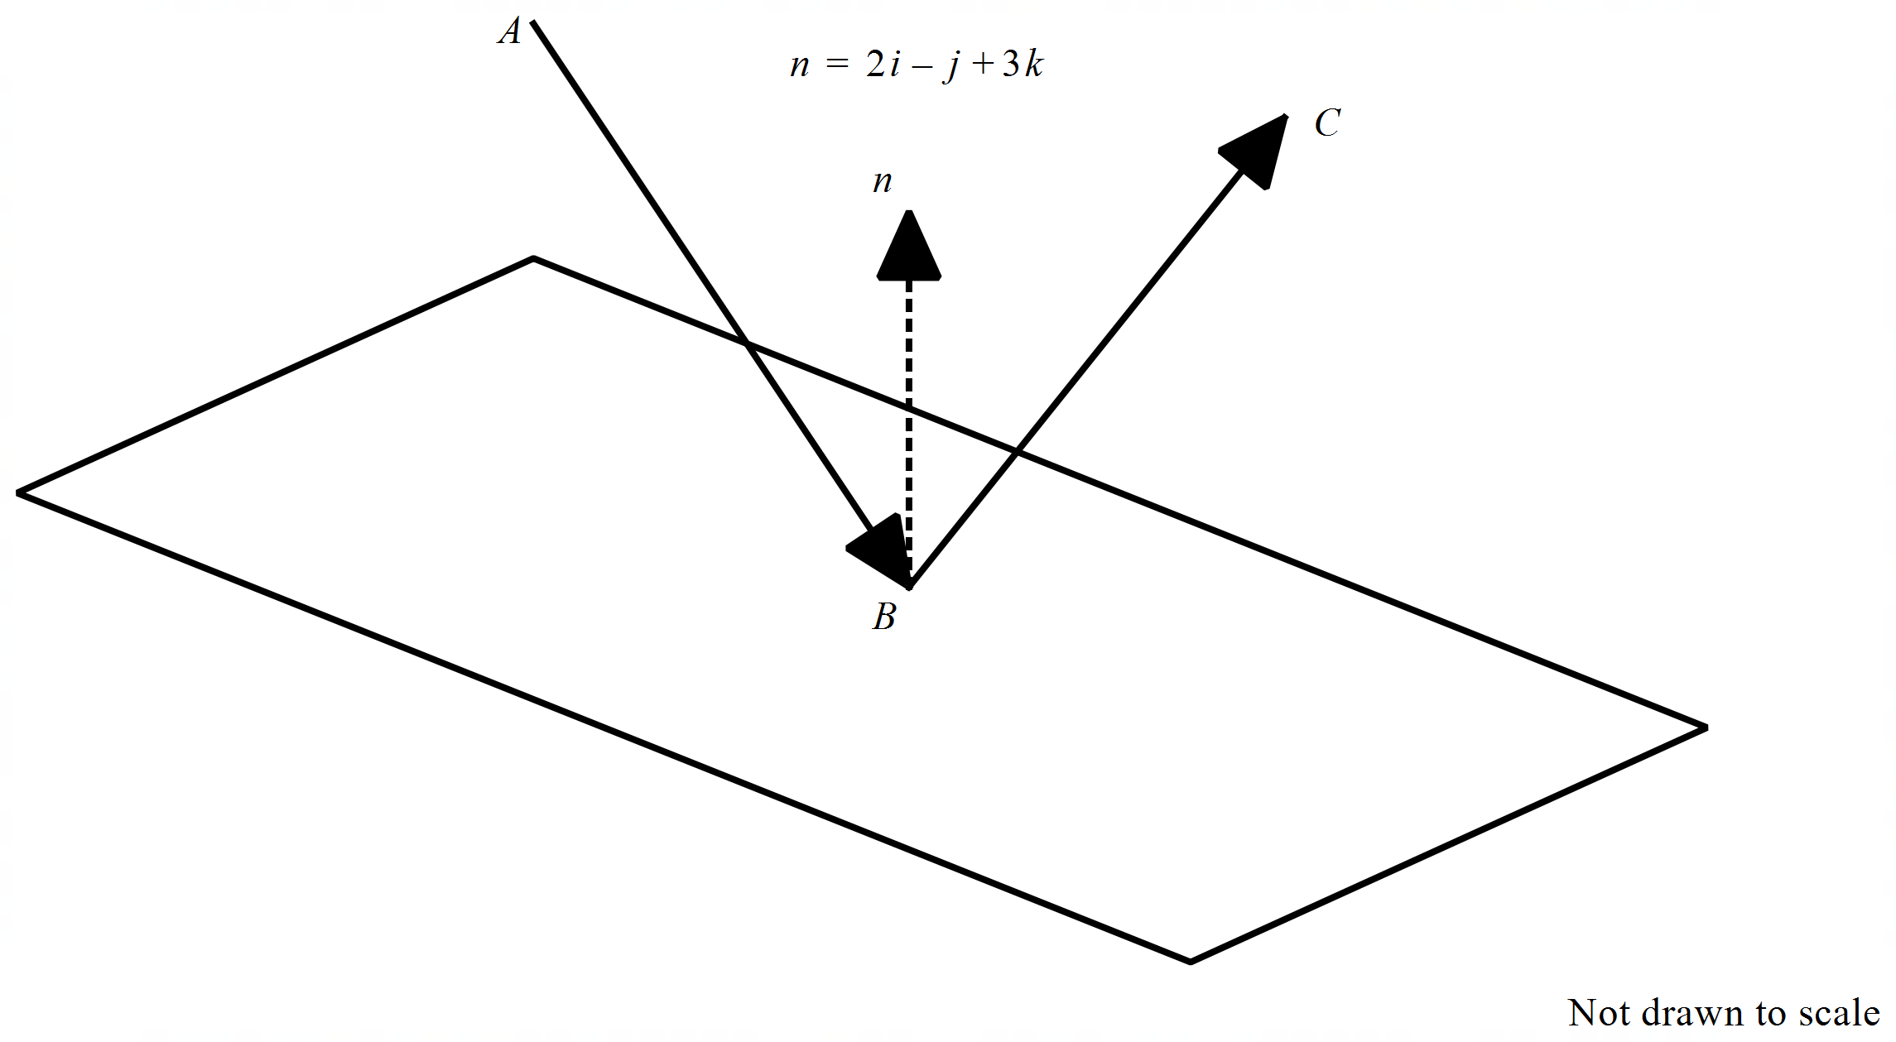

The projectile moves in the direction  and rebounds in the direction  with the same speed. The flat board has the equation . The angle of the incoming path and the normal  is equal to the angle of the outcoming path and the normal. Both paths &and the normal exist in the same plane.

Determine the velocity of the reflected projectile and the angle with the normal above to 2 decimal places.

|  |
| --- |
| **Solution** |
| Outgoing velocity = 7i+j+5k m/s at 30.22 degrees with normal |
| **Specific behaviours** |
| P determines speed of outgoing  P uses dot product with angles  P realizes that in going is obtuse with stated normal  P realizes that out going is obtuse with stated normal  P sets up two equations with 3 unknowns  P sets up three equations with 3 unknowns and solves for two sets of answers  P shows that one set is discarded (simply reverse)  Pstates velocity with approx. angle with normal (no need for 2dp) |

Q21 continued-

**Working out space**

**Working out space**

**Working out space**